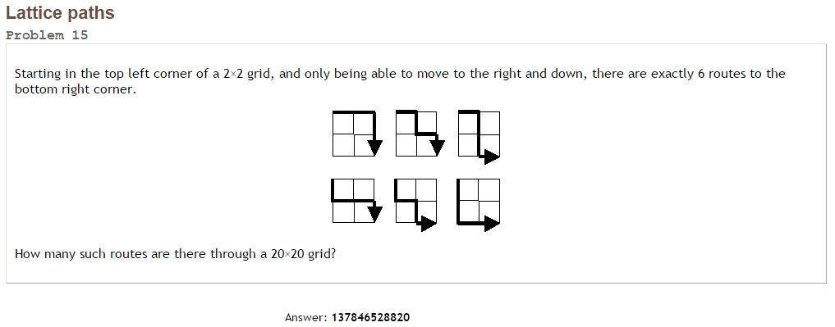Project Euler #15 – Pen & Paper Solution

In order to move from the top left corner to the buttom right coner move only right and down, we should move 20 steps for the right and 20 steps to the buttom. The order of the moves doesn’t matter.

In other word, the number of the valid routes equals to the number of choosing 20 positions out of 40.

Answer =  = [137846528820](http://www.wolframalpha.com/input/?i=40+c+20)